ASSIGNMENT – 05 (DBMS LAB)

* **PROBLEM:**

Create a table employe_roll number with attributes of empno,enamejob,hiredate,salary,commission,dept_no and insert values.

* **PROGRAM:**

create table employe_91(emp_no number(30),emp_name varchar2(30),job varchar2(30),mgr varchar2(30),hiredate date,salary number(30),comm varchar2(30),dept_no number(30),primary key(emp_no));

* **OUTPUT:**

Table created.

* **PROGRAM:**

Describe employe_91;

* **OUTPUT:**

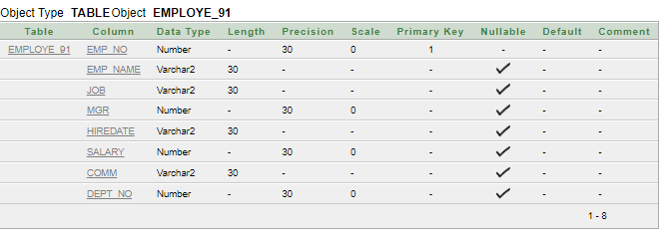

* **PROGRAM:**

begin

insert into employe_91 values('091','Ranjan Jana','MANAGER','8902','1990-10-18','1600.00','300.00','20');

insert into employe_91 values('092','Sayan Krmakar','ANALYST','8652','1992-12-15','2400.00','NULL','30');

insert into employe_91 values('093','sayan Dutta','MANAGER','8256','1990-9-13','1600.00','1300.00','20');

insert into employe_91 values('094','Shilpa Ojha','SALESMAN','8362','1990-10-9','1600.00','NULL','30');

insert into employe_91 values('095','sarolipi Pal','MANAGER','8456','1990-10-15','1600.00','400.00','20');

insert into employe_91 values('096','Sampad Kar','SALESMAN','8693','1990-10-28','1600.00','400.00','20');

insert into employe_91 values('097','Sanjoy Mannna','MANAGER','8325','1990-10-18','1600.00','NULL','30');

insert into employe_91 values('098','Raja Maity','SALESMAN','8311','1990-10-18','1600.00','500.00','20');

insert into employe_91 values('099','Swarup Jana','ANALYST','8652','1992-12-15','2400.00','600.00','20');

insert into employe_91 values('100','Bishwanath Jana','MANAGER','8362','1990-9-18','1600.00','700.00','20');

insert into employe_91 values('101','Suvadip Bera','SALESMAN','8874','1990-10-25','1600.00','NULL','30');

insert into employe_91 values('102','Furquan Mazity','SALESMAN','8423','1990-10-18','1600.00','1400.00','20');

insert into employe_91 values('103','Soumyaip Pal','MANAGER','8125','1990-10-18','1600.00','NULL','30');

insert into employe_91 values('104','Rahul Debnath','ANALYST','8652','1992-12-15','2400.00','00.00','20');

insert into employe_91 values('105','Sourav Roy','SALESMAN','8369','1990-10-18','1600.00','NULL','30');

insert into employe_91 values('106','Bikram Bera','SALESMAN','8789','1990-10-18','1600.00','300.00','20');

insert into employe_91 values('107','Prabin Jha','MANAGER','8457','1990-10-18','1600.00','00.00','20');

insert into employe_91 values('108','Prasun Jana','SALESMAN','8321','1990-10-18','1600.00','NULL','30');

insert into employe_91 values('109','Palash Bera','ANALYST','8652','1992-12-15','2400.00','300.00','20');

insert into employe_91 values('110','Guddu Mallik','SALESMAN','8342','1990-10-18','1600.00','200.00','20');

insert into employe_91 values('111','olivia Jana','MANAGER','8921','1990-10-18','1600.00','300.00','20');

insert into employe_91 values('112','Alfred Novel','SALESMAN','8364','1991-8-12','1600.00','NULL','30');

insert into employe_91 values('113','Mamata Chowdhury','MANAGER','8895','1991-9-17','1600.00','300.00','20');

insert into employe_91 values('114','Sweta Ojha','SALESMAN','8256','1990-8-20','1600.00','300.00','20');

insert into employe_91 values('115','Sayak Panda','MANAGER','8213','1990-10-18','1600.00','NULL','30');

insert into employe_91 values('116','Bisa Bhuima','ANALYST','8652','1992-12-15','2400.00','800.00','20');

insert into employe_91 values('117','Md Azad','MANAGER','8625','1990-8-29','1600.00','700.00','20');

insert into employe_91 values('118','Diptesh Biswas','ANALYST','8652','1992-12-15','2400.00','NULL','30');

insert into employe_91 values('119','kavaya singh','MANAGER','8962','1992-24-24','1600.00','1300.00','20');

insert into employe_91 values('120','Rahul Mazumdar','SALESMAN','8565','1991-10-5','1600.00','2300.00','20');

end

* **OUTPUT:**

Statement processed.

* **OUTPUT:**

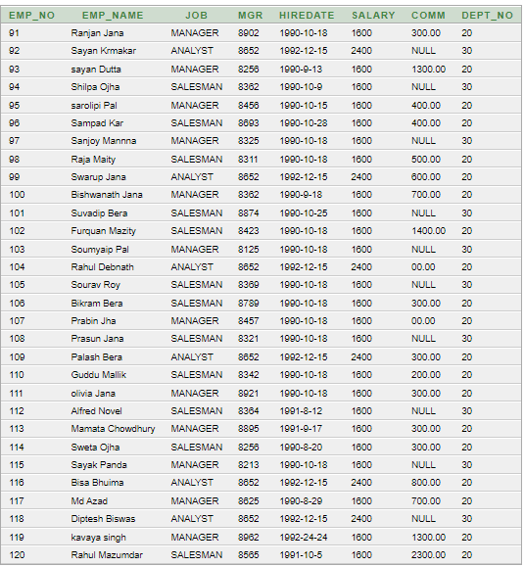

* **PROBLEM:**

Write a query to display EName and Sal of employees whose salary are greater than or equal to 2200?

* **PROGRAM:**

select emp_name,salary from employe_91 where salary>=2200;

* **OUTPUT:**

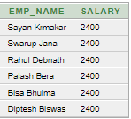

* **PROBLEM:**

Write a query to display details of employs who are not getting commission?

* **PROGRAM:**

select emp_name,job from employe_91 where comm='NULL';

* **OUTPUT:**

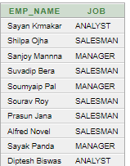

* **PROBLEM:**

Write a query to display employee name and salary of those employees who don't have their salary in range of 2500 to 4000.

* **PROGRAM:**

select emp_name,salary from employe_91 where salary not between 2500 and 4000;

* **OUTPUT:**

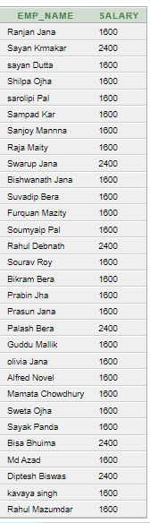

* **PROBLEM:**

Write a query to display the name, job title and salary of employees who don't have manager.

* **PROGRAM:**

select emp_name,job,salary from employe_91 where job!='MANAGER';

* **OUTPUT:**

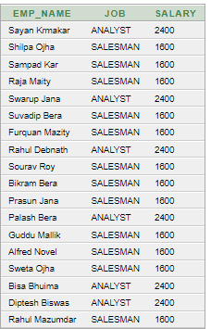

* **PROBLEM:**

Write a query to display the name of employee whose name contains "I" as third alphabet.

* **PROGRAM:**

select emp_name from employe_91 where emp_name like '_I%';

* **OUTPUT:**

No data found.

* **PROBLEM:**

Write a query to display the name of employee whose name contains "A” as last alphabet.

* **PROGRAM:**

select emp_name from employe_91 where emp_name like 'a%';

* **OUTPUT:**

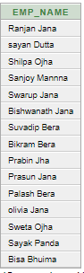

* **PROBLEM:**

Write a query to display details of employs with the text "Not given", if commission is null?

* **PROGRAM:**

select emp_name,'Not Given' from Employe_91 where comm='NULL';

* **OUTPUT:**

